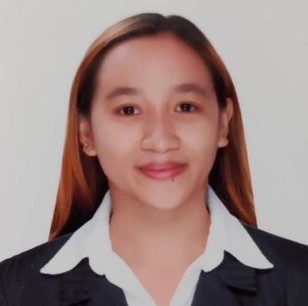**CHRISTIAN S. MORENO**

Brgy. Jamin-ay Calinog, Iloilo

09566700654

christianmoreno975@gmail.com

**Professional Summary**

Pursuing opportunity which will allow me to share my knowledge and skills at the same time I am more than willing to learn more to enhance my professional skills and behaviour, to serve and to be a part of this company.

**Work Experience**

* COASTALINK SHIPPING CORPORATION

2ND Floor, Ferlaw Building,366 Cabildo Street Intramuros, Manila, Philippines 1002

ENGINE CADET

February 7, 2021- February 10, 2022

**Highlights**

* Cooking
* Ability to plan well and prioritize work
* Maintain calmness under tight pressure
* Trustworthy, optimistic, hard-working, honest and service-oriented

**Educational Attainment**

Tertiary: **Bachelor of Science in Marine Engineering**

Magdalo Street. Lapaz Iloilo City

Year Graduated: 2019-2020

Secondary: Esteban S. Javellana Memorial High School

Brgy. Guiso Calinog, Iloilo

Year Graduated: 2012-2013

**Character References**

**Steve Tomas Y. De La Cruz**

Messenger/Liaison Personnel

Central Philippine University

Lopez Jaena Street Jaro, Iloilo City